**DEVICE DRIVERS**

**Definition**: it is a special kind of software application that controls a specific hardware device that enables different hardware devices to communicate with computer OS.

* It communicates with the computer hardware by computer subsystem or bus connected to hardware
* **Device Drivers** are essential for a computer system to work properly because without a device driver the hardware fails to work accordingly, which means it fails in doing the function/action it was created to do. Most use the term **Driver,**but some may say **Hardware Driver**, which also refers to the **Device Driver.**

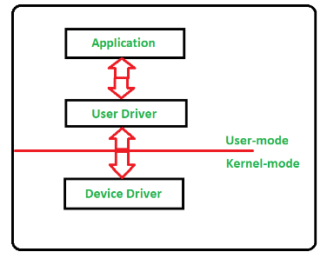

* Device Drivers depend upon the Operating System’s instruction to access the device and perform any particular action. After the action, they also show their reactions by delivering output or status/message from the hardware device to the Operating system
* For example, a printer driver tells the printer in which format to print after getting instruction from OS, similarly, A sound card driver is there due to which 1’s and 0’s data of the MP3 file is converted to audio signals and you enjoy the music. Card reader, controller, modem, network card, sound card, printer, video card, USB devices, RAM, Speakers, etc need Device Drivers to operate.

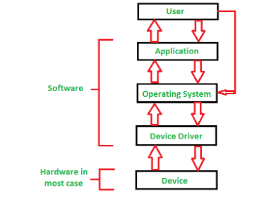

Device driver broadly divide into 2 types:

1. **Kernel-mode Device Driver –**   
   This Kernel-mode device driver includes some generic hardware that loads with the operating system as part of the OS these are BIOS, motherboard, processor, and some other hardware that are part of kernel software. These include the minimum system requirement device drivers for each operating system.
2. **User-mode Device Driver –**   
   Other than the devices which are brought by the kernel for working the system the user also brings some devices for use during the using of a system that devices need device drivers to function those drivers fall under User mode device driver. For example, the user needs any plug-and-play action that comes under this.

Applications: device drivers used in

1. Superior video performance
2. Mobile operating systems like android
3. Digital cameras
4. I/O devices
5. Accessing storage systems

